VW.COM SURVEY WEB SERVICE & KUBA INTEGRATION

High Level Design

Introduction
This document summarizes high level design aspects of the vw.com surveys web service and its integration with KuBa system. The diagram below shows how the end-to-end integration works.

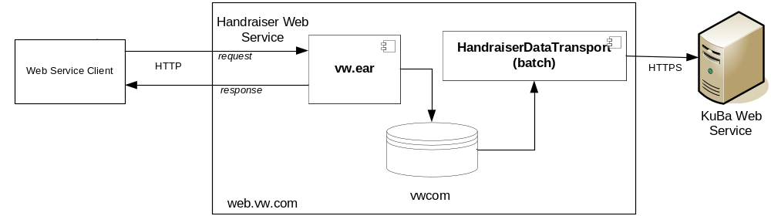

Figure 1 Integration of vw.com survey web service and KuBa.

The surveys will be handled as part of the existing handraiser web service in web.vw.com. The handraiser web service exposes a simple XML-over-HTTP API where XML messages based on a particular schema are sent to the web service via HTTP protocol. The existing schema will be extended to include the survey data. The XML document with survey data will be processed and stored in vwcom database instance similar to rest of the handraiser data. An immediate response will be sent back to the web service client for confirmation of receiving & processing the request.

A batch process will then read the handraiser data, including survey, from database and submit it into KuBa web service using a KuBa specific SOAP based protocol.

Notes:
- In general, a handraiser request does not have to contain survey data. Existing handraiser data format without surveys remains intact.
- A survey has to be part of a handraiser campaign. A handraiser request with survey data will have an additional component on top of existing handraiser data format.
- Before data for a particular survey can be submitted to web.vw.com, survey and campaign meta-data for the survey must be provided to web.vw.com MRO.

Main Solution Components

handraiser.xsd
This is an XML schema that describes XML message format for handraiser requests.
- Existing component.
- It will be extended to contain an optional component to contain survey data.

ProcessHandraiserAction
This Java class is part of com.vw.web.actions package and acts as an entry point for the handraiser web service. This class validates the XML message, representing handraiser request, and forwards it to CommonServices for creation of a survey entry.
- Existing component.
- No changes are envisioned for this component.

CommonServices
This Java interface and its implementation are part of com.vw.common.ejb3 package and are responsible for parsing the XML message and storing the handraiser data in database.
- Existing component.
- The method createHandraiser() will be updated to extract, if exists, survey data and save it in database as part of the handraiser request.

Survey Data Model
This is a relational data model representing the survey data in database. It is implemented via the survey tables described below.
- New component.

Survey Tables
Those are various database tables created according to the Survey Data Model mentioned above. They are implemented in MySQL vwcom instance.
- New components.
- Survey table represents survey meta-data
- HandraiserSurvey table represents mapping between HandraiserCampaign and Survey tables
- SurveyEntry table represents the additional survey data in a handraiser request
  - SurveyEntry table is going to have a VARCHAR(65000) data type to store survey questions/answers. Since latin1 character set (current character set in vwcom database) uses 1 byte per character, we can store up to 65,000 characters of data per survey entry. (The example provided to MRO contains < 2,500 characters!)

Handraiser Templates
Those are XML templates used to dynamically create an XML document to be sent to KuBa web service. They are intended to be consumed by the existing netpub library.
- Existing component.
- handraiserCampaign.tpl should be modified to include survey data element

HandraiserDataTransport
This Java class is responsible for reading handraiser data, including survey, from database and submitting it to KuBa web service. It utilizes the Survey Tables and Handraiser Templates mentioned above.
- Existing component.
- Uses regular JDBC to read the survey data from survey tables.

